

NAME: BISMA FATIMA
CLASS: CS A
ROLL NO: F24605036
COURSE: ARTIFICIAL INTELLIGENCE
COURSE CODE: CS-281
LECTURER: SIR IJLAL HAIDER

LAB 04

IN LAB TASKS
Task 1
Write a Python function to perform Depth-First Search (DFS) on a given graph represented as a dictionary. The graph will be defined such that the keys are nodes, and the values are lists of neighbouring nodes. The function should print the nodes as they are visited.
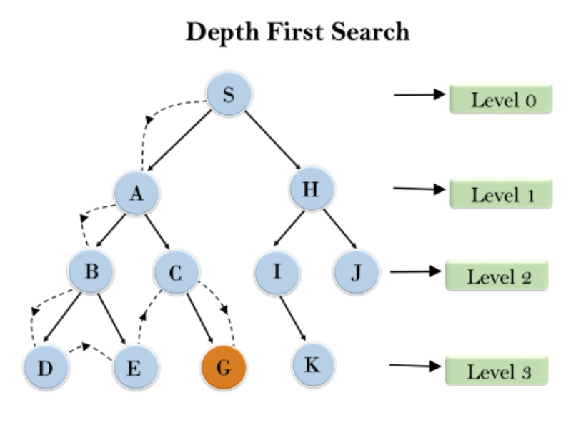
PROGRAM
1. def dfs(graph, start):
2. visited = set()
3. traversal_order = []
4.
5. def dfs_helper(node):
6. visited.add(node)
7. print(node, end=" ") # Print node as it's visited
8. traversal_order.append(node)
9. for neighbor in graph[node]:
10. if neighbor not in visited:
11. dfs_helper(neighbor)
12.
13. dfs_helper(start)
14. return traversal_order
15.
16. # Example usage with the graph in the image
17. graph = {
18. 'S': ['A', 'H'],
19. 'A': ['B', 'C'],
20. 'B': ['D', 'E'],
21. 'C': [],
22. 'D': [],
23. 'E': [],
24. 'H': ['I', 'J'],
25. 'I': ['G'],
26. 'J': ['K'],
27. 'K': [],
28. 'G': []
29. }
30.
31. start_node = 'S'
32. print("DFS Traversal:")
33. dfs(graph, start_node)

OUTPUT
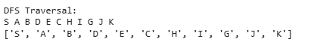
Task 2
Write a Python function to perform Uniform Cost Search (UCS) on a given graph. The graph will be represented as a dictionary, where each key is a node and the value is a list of tuples, each containing a neighbouring node and the cost to reach that neighbour. The function should find the least-cost path from a starting node to a goal node and print the path along with the total cost.
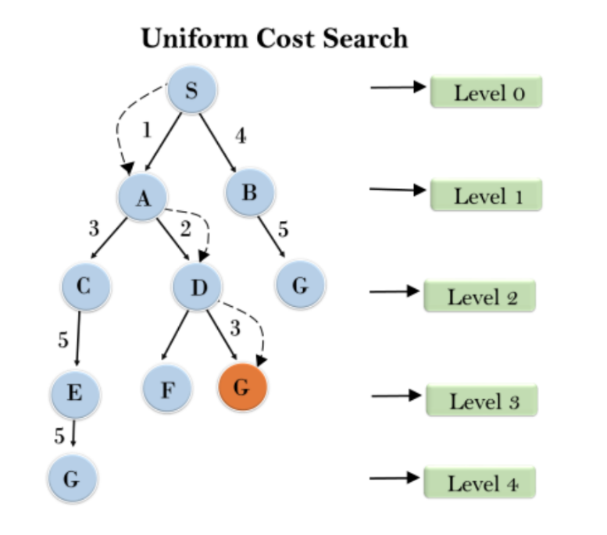

PROGRAM
1. import heapq
3. def uniform_cost_search(graph, start, goal):
4. # Initialize priority queue with the start node
5. queue = [(0, start, [])] # (cost, node, path)
6. visited = set()
7.
8. while queue:
9. cost, node, path = heapq.heappop(queue)
10. if node not in visited:
11. visited.add(node)
12. path = path + [node]
13. if node == goal:
14. print(f"Path: {' -> '.join(path)}")
15. print(f"Total Cost: {cost}")
16. return
17. for neighbor, neighbor_cost in graph[node]:
18. if neighbor not in visited:
19. heapq.heappush(queue, (cost + neighbor_cost, neighbor, path))
20. print("No path found to the goal node.")
22. # Example graph from the image
23. graph = {
24. 'S': [('A', 1), ('B', 4)],
25. 'A': [('C', 3)],
26. 'B': [('D', 2), ('C', 5)],
27. 'C': [('E', 5)],
28. 'D': [('F', 7), ('G', 7)],
29. 'E': [('G', 5)],
30. 'F': [],
31. 'G': []
32. }
34. # Example usage
35. start_node = 'S'
36. goal_node = 'G'
37. uniform_cost_search(graph, start_node, goal_node)

OUTPUT
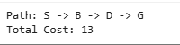
Task 3
Write Python code to traverse the following graph using BFS and DFS starting from node S. Print the nodes in the order they are visited.
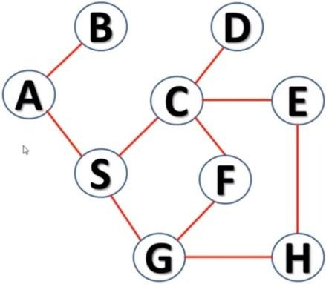
PROGRAM
1. from collections import deque
2.
3. def bfs(graph, start):
4. visited = set()
5. order = []
6. queue = deque([start])
7. visited.add(start)
8.
9. while queue:
10. node = queue.popleft()
11. order.append(node)
12. for neighbor in graph[node]:
13. if neighbor not in visited:
14. visited.add(neighbor)
15. queue.append(neighbor)
16. return order
17.
18. graph = {
19. 'S': ['A', 'C', 'G'],
20. 'A': ['B', 'S'],
21. 'B': ['A'],
22. 'C': ['D', 'E', 'F', 'S'],
23. 'D': ['C'],
24. 'E': ['C'],
25. 'F': ['C', 'H'],
26. 'G': ['S'],
27. 'H': ['F']
28. }
29.
30. bfs_order = bfs(graph, 'S')
31. print("BFS Order:", bfs_order)

OUTPUT
POST LAB TASKS
Task 1
Write Python code to traverse the following graph using BFS and DFS starting from node a. Print the nodes in the order they are visited.
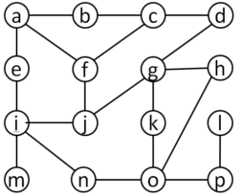
PROGRAM
1. from collections import deque, defaultdict
2.
3. # Define the graph using adjacency list
4. graph = defaultdict(list)
5. graph['a'] = ['b', 'e']
6. graph['b'] = ['a', 'f', 'c']
7. graph['c'] = ['b', 'g', 'd']
8. graph['d'] = ['c', 'h']
9. graph['e'] = ['a', 'i', 'f']
10. graph['f'] = ['b', 'e', 'g', 'j']
11. graph['g'] = ['c', 'f', 'k']
12. graph['h'] = ['d', 'l']
13. graph['i'] = ['e', 'j', 'm']
14. graph['j'] = ['f', 'i', 'n', 'o']
15. graph['k'] = ['g', 'o']
16. graph['l'] = ['h', 'p']
17. graph['m'] = ['i']
18. graph['n'] = ['j']
19. graph['o'] = ['j', 'k', 'p']
20. graph['p'] = ['l', 'o']
21.
22. def bfs(start_node):
23. visited = set()
24. order = []
25. queue = deque([start_node])
26. visited.add(start_node)
27.
28. while queue:
29. node = queue.popleft()
30. order.append(node)
31. for neighbor in graph[node]:
32. if neighbor not in visited:
33. visited.add(neighbor)
34. queue.append(neighbor)
35. return order
36.
37. def dfs(start_node):
38. visited = set()
39. order = []
40. stack = [start_node]
41. visited.add(start_node)
42.
43. while stack:
44. node = stack.pop()
45. order.append(node)
46. for neighbor in reversed(graph[node]): # To maintain alphabetical order in case of multiple neighbors
47. if neighbor not in visited:
48. visited.add(neighbor)
49. stack.append(neighbor)
50. return order
51.
52. # Perform traversals starting from 'a'
53. bfs_order = bfs('a')
54. dfs_order = dfs('a')
55.
56. print("BFS Traversal Order:", bfs_order)
57. print("DFS Traversal Order:", dfs_order)

OUTPUT
Task 2
For the given graph write a Python code to implement Uniform Cost Search (UCS) to find the shortest path from node V1 to node V6.
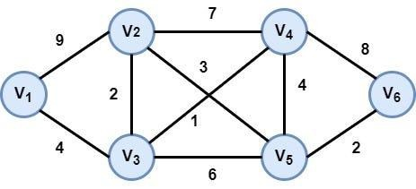

PROGRAM
1. import heapq
2.
3. def uniform_cost_search(graph, start, goal):
4. # Initialize priority queue with the start node
5. queue = [(0, start, [])] # (cost, node, path)
6. visited = set()
7.
8. while queue:
9. cost, node, path = heapq.heappop(queue)
10. if node not in visited:
11. visited.add(node)
12. path = path + [node]
13. if node == goal:
14. return cost, path
15. for neighbor, edge_cost in graph[node].items():
16. if neighbor not in visited:
17. heapq.heappush(queue, (cost + edge_cost, neighbor, path))
18. return float("inf"), []
19.
20. # Define the graph
21. graph = {
22. 'V1': {'V2': 9, 'V3': 4},
23. 'V2': {'V1': 9, 'V4': 7},
24. 'V3': {'V1': 4, 'V4': 3, 'V5': 6},
25. 'V4': {'V2': 7, 'V3': 3, 'V6': 8},
26. 'V5': {'V3': 6, 'V6': 2},
27. 'V6': {'V4': 8, 'V5': 2}
28. }
29.
30. start_node = 'V1'
31. goal_node = 'V6'
32.
33. cost, path = uniform_cost_search(graph, start_node, goal_node)
34.
35. print(f"Shortest path from {start_node} to {goal_node}: {path}")
36. print(f"Cost: {cost}")

OUTPUT
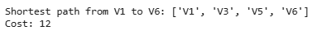
Task 3
For the below graph write Python code to find the shortest path from node 2 to node 4 using UCS. Write complete order for the traversal.

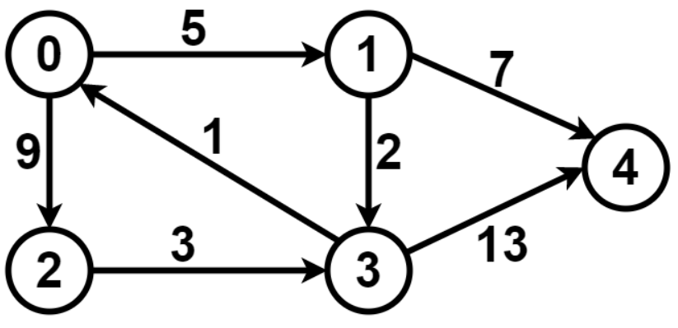
PROGRAM
1. import heapq
2.
3. def ucs(graph, start, goal):
4. queue = [(0, start, [])] # (cost, node, path)
5. visited = set()
6.
7. while queue:
8. cost, node, path = heapq.heappop(queue)
9. if node not in visited:
10. visited.add(node)
11. path = path + [node]
12. if node == goal:
13. return cost, path
14. for neighbor, edge_cost in graph.get(node, {}).items():
15. if neighbor not in visited:
16. heapq.heappush(queue, (cost + edge_cost, neighbor, path))
17. return float("inf"), []
18.
19. # Define the graph
20. graph = {
21. 0: {1: 5, 2: 9},
22. 1: {3: 2, 4: 7},
23. 2: {3: 3},
24. 3: {4: 13},
25. 4: {}
26. }
27.
28. # Find shortest path from node 2 to node 4
29. start_node = 2
30. goal_node = 4
31. cost, path = ucs(graph, start_node, goal_node)
32.
33. print(f"Shortest path from node {start_node} to node {goal_node}: {path}")
34. print(f"Cost: {cost}")

OUTPUT
